Report March 2012

2012
Wentworth Street Car Park or The Cattle Market
A report by Paul Andrews LLB, BA, solicitor and Paul Beanland FRICS, Chartered Surveyor

1This report is prepared jointly by:
  - Paul Andrews LLB, BA.; and

  - Paul Beanland FRICS, Chartered Surveyor.

- Paul Andrews worked as a local government solicitor for over 23 years – during 18 of them in senior positions. He specialised in planning advocacy during the 8 years he worked for Ryedale – at the peak doing more than one public enquiry a month.

- Paul says: “When preparing for planning enquiries, I had to study all the reports prepared by the developers’ agents, so that I could cross-examine their professional representatives”.

- Paul therefore has the necessary knowledge, qualifications and experience to examine all kinds of planning documents.

- Paul Beanland is a leading local surveyor (recently retired), a Fellow of the Royal Institution of Chartered Surveyors, and has been in practice in North Yorkshire and Humberside for most of his career.

- He was a partner in Cundalls in the early 70’s, being involved in the firm’s expansion from 2 to 17 offices and leading much of its initial developemtn into estate agency and non-agricultural work.

- He opened his own firm, Paul Beanland and Associates in 1992 in Malton after Wells Cundall was sold to Nationwide Building Society, when he ran a mixed practice of estate agency, commercial agency, professional services, planning and development. During this time he joined Peter Illingworth in also opening an estate agency in Pickering (Beanland, Illingworth)

- At all times he has been familiar with local businesses and, as a qualified valuer, he understands the impact of unwelcome development on town centres and its effect on established retail trading.
- Paul Andrews and Paul Beanland together have the necessary knowledge, qualifications and experience to comment with some authority on most planning applications and consultants’ reports which deal with town centre retail issues.

- Through mixing and meeting with local people and hearing their aspirations and worries, they have in-depth local knowledge which bought-in consultants cannot emulate.

- When examining Consultants’ Reports, we do not challenge their data, unless we have our own alternative data. What we can challenge is some of the assumptions which are used to manipulate the data, and which we feel may not provide a true local picture which local people would recognise. In particular, we challenge two vital assumptions which underpin the Consultants’ reports which the Council and the Developers rely on.

Mistaken Assumption No. 1.
- The Consultants are required by National Government Guidance to “establish the appropriate retail catchment area for the highest order centre being considered, in this case Malton” – RTP (Roger Tymm and Partners) Report July 2011 p.28, para 4.6.

- The catchment area for Malton which RTP have drawn includes the land within the outer blue line on their “Figure 3.1” which is reproduced below. This catchment area is referred to as “RTP’s blue line OCA” throughout the remainder of this report.
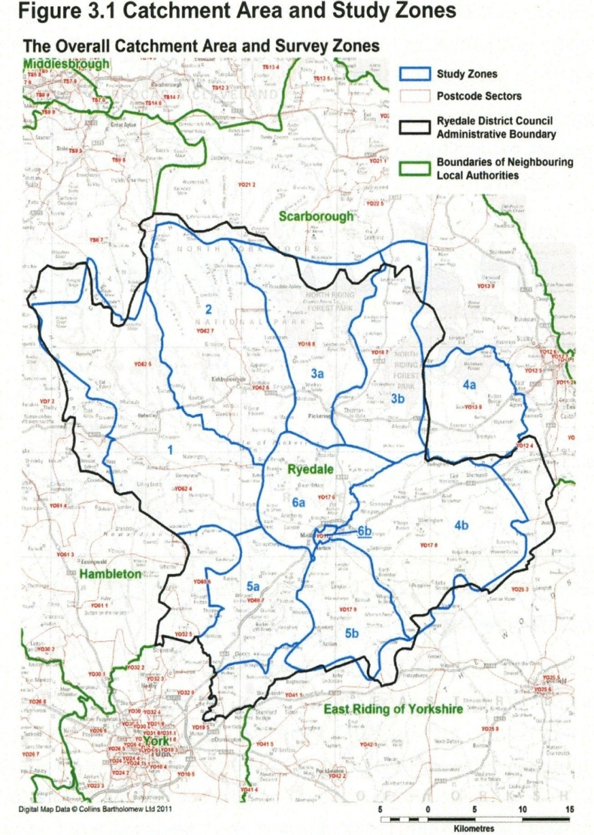
- It will be seen that this “Overall Catchment Area” (OCA)is almost coextensive with the black line which indicates the boundary of Ryedale District. It will be seen that the boundary of this catchment area extends almost as far as York , Beverley, Driffield, Thirsk and Scarborough. The black line represents the district council’s area of control, but not, we suggest, the way people tend to shop.

- Paul Beanland has prepared the plan which is reproduced next below. He thinks Malton’s catchment area is largely defined by the red line on this plan, and that from this watershed shoppers will go to the easiest and most convenient retail outlets – often the sub-regional centres in Scarborough and York, and other district centres such as Thirsk, Easingwold , Beverley, Filey, Driffield and Pocklington.

- Paul Beanland’s professional opinion is that RTP’s catchment area is misleading, as they are saying that 85% of residents who live within RTP’s blue line OCA should shop in Malton.

PAUL BEANLAND’S PLAN
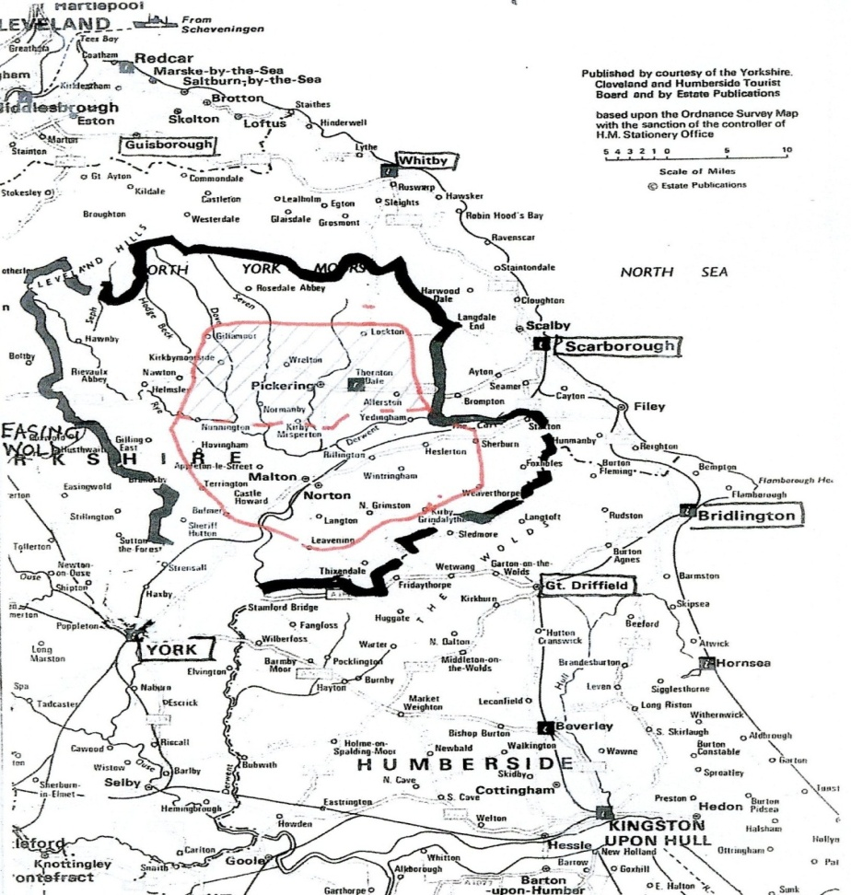

Important definitions:
- “Convenience Products” are consumable goods which form part of our weekly shop. They include food, cleaning products, toiletry etc. These are products which are usually sold in supermarkets.
- “Comparison Products” are everything else, including clothing, electrical, furniture, pots and pans etc. This can include major items of expenditure – eg. motor cars. Comparison good are not normally sold in supermarkets, but many are sold in super stores.

- As regards Convenience Products:

- Para 4.33 of the Report of Nathaniel Lichfield, which accompanies Holbeck’s planning application for Wentworth Street Car Park forecasts that the new store would have an annual convenience goods turnover of £28M. This equates to the money which they expect the public to spend on their products, and roughly equates to what RTP call “convenience goods expenditure”.

- The question is: where is this convenience turnover going to come from?

- The following quotation and Table come from the RTP Report of July 2011 referred to previously (Para. 3.36 P. 19)
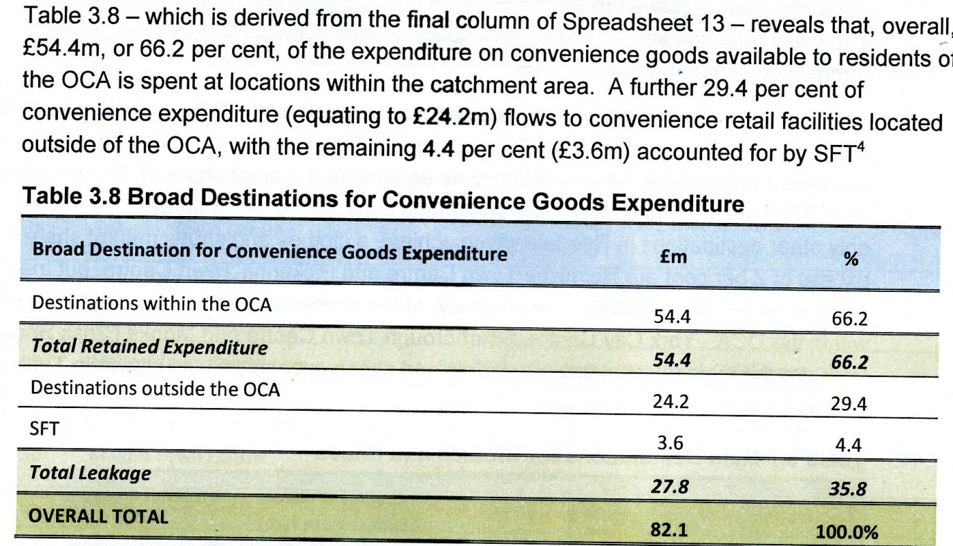
- In other words, what RTP are saying is that Residents within their OCA (Overall Catchment Area) spend £27.8M on Convenience goods in stores which are outside their OCA (the blue line on their Figure 3.1 reproduced above. ALL OF THE REST IS SPENT INSIDE RTP’s blue line OCA.

- The £27.8M is described as a “leakage”. However, if one were to take the view that the population of the area within the red line on Paul Beanland’s plan is approximately two thirds of the population of RTP’s blue line catchment area, it would seem that approximately the right proportion of convenience expenditure is already being spent within the red watershed line identified by Paul Beanland.

- Nathaniel Lichfield are saying that a new store on WWSCP would take £23.8M “from the study area” – ie from the area within RTP’s blue line – the OCA identified by RTP.

- One has to consider if this is realistic. In doing so, regard should be had to Table 3.10 on page 20 of RTP’s July 2011 Report. This shows the “Main Destination for Convenience Goods Expenditure Leakage”:

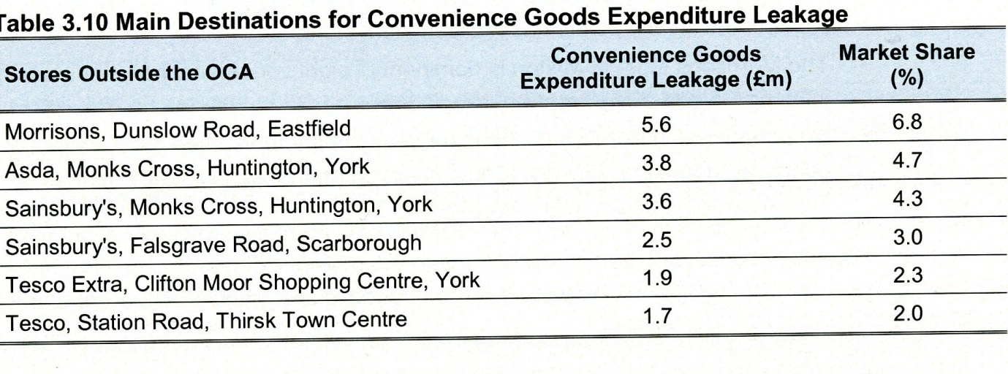
- Bearing in mind that York and Scarborough are both sub-regional centres and have a far stronger draw than a district centre like Malton or Pickering, is it really likely that people who shop at these places are likely to change their shopping habits just because there is a new superstore in Malton? And this need not take into account the obvious difficulties of highway access from the A 64.

- We’ll tell you where the extra £28M is going to come from:

- From Malton and Norton shops: but not just Malton and Norton shops, for shops in Pickering, Kirby Moorside, Thornton-le Dale, Helmsley and the rural areas will suffer as well. Retail activity in all these town centres will decrease, and for many businesses it will be the last straw, the thing which causes them to give up.

- And if you want your local village shop with its local post office to continue in business, forget it – it will be a lost cause.
- As regards Comparison Goods, the Wentworth Street developers say the new proposed store will have an annual turnover of comparison goods of £ 7.9M. Where is this going to come from?

- The table below, taken from the same RTP Report, shows the total comparison retail expenditure retained in RTP’s OCA as £43.3M. This amounts to 30.1% of all annual comparison expenditure within RTP’s blue line OCA.
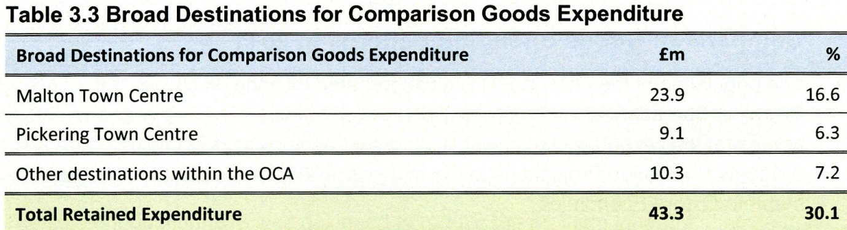

- The next table, taken from the same RTP Report, shows the amount of Comparison Expenditure “lost” from RTP’s blue line OCA as being £100.4M. So the total comparison expenditure from residents within RTP’s blue line OCA is £143.8M.
£M %
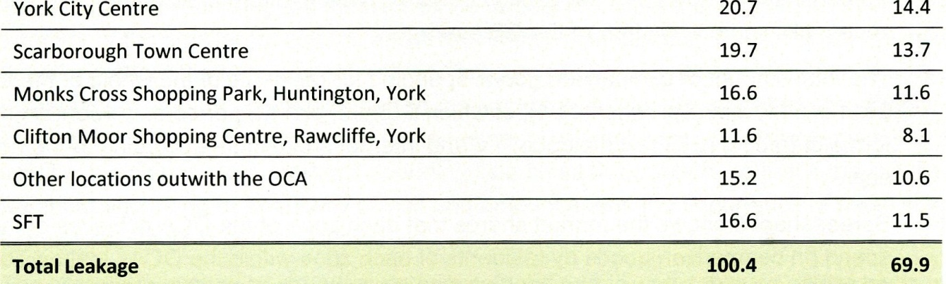
- At first sight, it might appear that the new store should have no difficulty in seeking to “recover” £7.9M of “lost” expenditure without damaging existing shops within RTP’s blue line OCA.

- However, even Nathaniel Lichfield acknowledge that the centres outside RTP’s blue line OCA are very difficult to beat. So they say they would only expect their new store to “recapture” between 5% and 10% of the total amount of comparison expenditure – ie. between £14.3M and £7.15M (para 4.39 Nathaniel Lichfield P.20).

- This means that, if there is an increased retention of only £7.15M, the new superstore will be taking trade from other shops within RTP’s blue line OCA, and weakening existing shopping centres within Ryedale.

- However, if there is an increased retention of more than 5%, the existing town centres might benefit.

- Unfortunately it is unlikely that there will be enough comparison trade for both the new superstore and for existing shops in any event for the following reason:

- The two elements of comparison and convenience retail are linked. The assumption is being made that something has to be done to encourage more shoppers to shop in Malton. The theory is that the new superstore will increase the retention of convenience expenditure by 20%. The assumed 5% - 10% increased retention of comparison expenditure is predicated on this. It follows that, if the new superstore cannot increase the retention of convenience goods by 20%, then there will be no increased retention of comparison goods of the order of 5% - 10%.

- It is already clear from our comments on Convenience retail, that the assumed increased retention of convenience expenditure is unlikely to be achieved. It follows therefore that the assumed increase in comparison expenditure will also not be achieved.

- So, if the new superstore cannot take its expected £7.9M annual turnover of comparison goods by increasing the retention of comparison expenditure, where will it get its customers from?

- Answer: The new superstore will take much of its comparison trade from local shops in Malton, Pickering, Helmsley, Kirby Moorside – and all that will be left will be mostly tourist gift shops, banks and building societies.

- Is this what we want to see in Ryedale?

- Further, superstores usually appeal to the lower end of the market. Ryedale is a low wage area. So, as most shops, at least partly, go for the low wage market (ie. the lower end of the market), the superstore will be in direct competition with all of them.

- Direct competition means not just competition on price.

- It means, for example, competition on opening times – superstores can do 24 hour opening if it suits them.

- And the superstore will be a one-stop shop.

- Why visit Pickering town centre, say, if you can get everything you want (food, clothes, electrical etc.) from a single visit to the big superstore in Malton?

Mistaken Assumption Number 2.

- The table below is taken from the same RTP report of July 2011 as above. It shows their projection of the “quantitative need” for new convenience retail floorspace up to 2026 (14 years away). This figure is given as 1,890 sq.m.

- But Ryedale have taken this figure and have directed that this amount of extra floorspace should be provided in Malton – not in 2026, but now (ie. to be built in 2013 – when according to the table there is a surplus )
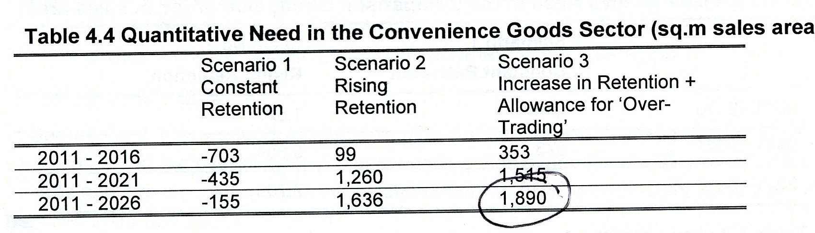
- The surplus is indicated by negative figures. The “Rising Retention” figures assume that convenience retail retention can be increased by 20% within a period of 15 years. We have already seen that this is impossible to achieve, bearing in mind the excessive size of RTP’s blue line catchment area.

Do the same considerations apply to the FME (Fitzwilliam Malton Estate) proposals for the redevelopment of the Cattle Market Area?

- In answering this question, it is important to point out that the July 2011 RTP Report, whilst providing no support for a new supermarket in Malton on grounds of quantitative need, does make out a case on grounds of qualitative need for “exploiting the redevelopment opportunities presented by the Cattlemarket site and Wentworth Street Car Park site, both of which are close to Malton’s existing town centre”.

- This is in stark contrast to their recommendations in earlier reports: their 2006 report identifying the Cattlemarket site as being “the primary opportunity to address deficiencies in the Malton retail offer, and the site holds the key to the future well-being of the town centre”, and their 2008 draft report clearly contains a full endorsement of FME’s 2007 planning application, and dismisses WWSCP as “not representing a short term development opportunity”.

- We do not believe that the current proposals for Wentworth Street Car Park have any merit in terms of qualitative need because the proposed superstore is too big, the site is in the wrong place, and the site is to be sold to the highest bidder after planning permission is obtained – thus making it impossible for the Council to have any say on the nature of the supermarket’s offer. We think the proposed store if built will undermine the vitality and viability of Malton and other Ryedale towns for these and the reasons previously stated.

- However, we do think the FME proposals to redevelop the Cattlemarket site do have merit in qualitative terms for the following reasons:

- The Cattle Market site is close to the town centre - it will draw shoppers to the historic town centre, instead of taking them away from it, as a store at WWSCP would.

- The food hall will be top range (a Waitrose or a Booths). As such it will fill a gap in the market, instead of competing at the middle or lower end of the market. It should therefore be no threat to any existing town centre.

- The FME food hall will not be a one-stop shop – shoppers will have to go to other shops within the town centre to complete their weekly shop.

- FME own about 60% of Malton’s town centre. It will not be in their interest to produce a development which could compromise or prejudice their own vested financial interest in Malton. In point of fact FME have continuously invested in Malton and are even now restoring the Talbot Hotel and other buildings.

- If the FME proposal goes ahead, what will happen to the Livestock Market?

- Answer: It is not possible to allocate land for a livestock market in a decision on a planning application – but it is possible to do this (and to look at funding and other issues) in the LDF, and land has been available for the Livestock Market to relocate to.

- Could all these applications be deferred so that the Cattle Market and WWSCP sites can be considered at the EIP into the Ryedale Plan?

- The officers will say: “No – a decision has to be made now”.

- We disagree.

- “The Planning System: General Principles 2005’ Para 17 says:
“In some circumstances, it may be justifiable to refuse planning permission on grounds of prematurity where a DPD is being prepared or is under review, but it has not yet been adopted. This may be appropriate where a proposed development is so substantial, or where the cumulative effect would be so significant, that granting permission could prejudice the DPD by predetermining decisions about the scale, location or phasing of new development which are being addressed in the policy in the DPD.”
- “DPD” means “development plan document”. These are normally issued after a “core strategy” document has been prepared, and deal with site allocation. We think the Council can rely on the principle of this circular, even though the DPD stage has not been reached – because both sites are already identified in the draft Ryedale Plan as being part of a “Northern Arc” (page 79 of the draft Ryedale Plan), and to this extent the draft Ryedale Plan is site specific and fulfils many of the purposes of site allocation under a DPD.

- If we are wrong, what can the developers do if the application is deferred?

- Answer: They can appeal against non-determination.

- If they appeal, when will their appeal be heard?

- The EIP into the draft Ryedale Plan is due before the end of the year.

- In these circumstances, is the inspectorate going to set a date for a public enquiry into an appeal which is earlier than the EIP?

- Isn’t the appeal inspector going to want to know the outcome of the EIP before he makes his decision?

- Conclusion: These are all very complex issues which are difficult for members to grasp. In all the circumstances, we think all the interested parties should have the opportunity to present their proposals to an impartial independent expert government inspector, preferably at the Examination in Public (EIP) into the draft Ryedale Plan. We would therefore invite the committee to defer all three applications so that both sites and every relevant issue can be considered at the EIP.

PAUL ANDREWS PAUL BEANLAND
21st March 2012

